Including Smaller Companies Shares in investment portfolios could improve returns.

Small caps have outperformed large caps over the last 15 years
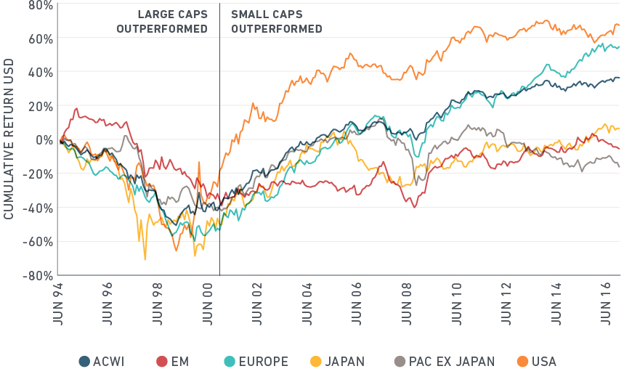

Allocating strategically to the smaller company stocks segment of global equity portfolios has been very important over many years, especially during the past 10 years. Following the financial crisis, small companies in a global equity portfolio add diversification benefits and about 0.5% PA to returns, (Research : MSCI 16 March 2017, over 15 years to June 2016)
Trading costs for small company stocks have reduced globally meaning that investing in a small cap indexes has become much more viable. The natural starting point for equity investors should be the global investable opportunity set, which includes all sizes of company capitalisation with 14% in the small company sector.
Including the small cap sector has increased the return on a global portfolio excluding the sector by 19% over the 15 years to June 2016 and in the US to March 2019 the small cap index has grown 22% more over the past 15 years. (Source: MSCI)

